Year 5 HOMEWORK Autumn 1 2026
Completing your homework every week will help you become the very best that you can be.
"Together in God's grace, may we give our children the roots to grow and the wings to fly"

Dear parents,
The following tasks will be invaluable in supporting your child’s learning in school. Your child should be able to complete most of the tasks themselves, thus improving their independent learning skills. However, your support will be welcome at all times. All pupils are expected to complete the homework tasks as stated below. Homework books need to be handed on the last Monday before half term.

Year 5 COOL activity grid
Please complete the activities in Red and then try to complete the other activities:

English  In English we are working towards writing a persuasive speech.  The features we will be focusing on are using linking adverbs, adjective openers and modal verbs.  Write a speech to argue should homework be a compulsory part of school. | Reading  Children should read at least three times a week for 15-20 minutes. This doesn’t always have to be the children’s reading book from school. When reading with children, concentrate on accuracy and check their understanding of what they have read. | Maths  Continue practicing times tables with TTrockstars.  We have looked at roman numerals at the beginning of the term.  Find numbers to convert into roman numerals. To challenge yourself, complete different calculations in roman numerals.
Science – Earth and Space  Create a poster to inform people on the characteristics of our universe.  Include facts about what is in the universe, how the planets manoeuvre and what scientists have discovered. You can include pictures and diagrams. | Art – Islamic art and architecture  Using recyclable materials create a structure and decorate it in the style of Islamic art.  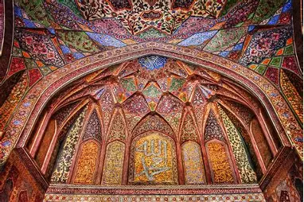 | School Values  This half-term’s focus value is forgiveness.  Create an acrostic poem for the word 'forgive'.  In an acrostic poem, the first letter of each line spells a word. The word is the subject of the poem.

