Year 1 COOL Activity Grid
(Carrying On Our Learning)
Please complete the activities in Red and then try to complete at least one of the other activities.
Keep an eye on the class page, as we will post ideas throughout the term.
Make sure you can read and spell all the common exception words.  I have put a picture of the whole list of Year 1 common exception words below.  If you can already read and spell the words continue using them in sentences. Make sure you extend your sentences adding in more detail and use your neatest handwriting.  You could use them in a story. We have included a story ideas grid. | Reading  Read a book …  - By the author Julia Donaldson.  - About space.  - That makes you laugh.  - That has an animal as the main character.  - That is a fairy tale.  Also try reading:  - Outside  - With a torch  - In a den you have made  - Out loud to someone new  - With your best friend. | Money  In Maths, we will be looking at money.  Set up a shop for you to buy things from, e.g. a toy shop or a healthy food shop.  At the shop I would like you to use amounts under £1 and think about how you can make that exact amount using the different coins.
DT - Windmills  In DT, we are designing and making a windmill.  Can you find examples of things which use wind?  Can you make a poster of pictures of items which use wind? | Art - Portraits  In Art, we will be looking at and drawing portraits.  Can you find examples of portraits?  Who are the people in the picture and the artists?  You could create a portrait of a famous person or a family member. | RE – How can we take care of the world and others.  In RE we will be looking at how Christians look after others and why it is important we look after the world we live in.  Create rules that you believe we should all live by so others and the world are cared for.  You could create a song to showcase your rules, maybe a book or poster.
Remember to record what you have done in your homework. You could take a photo, write down or stick in the things you have done. We can’t wait to see what you get up to.
Mrs Powell and Mrs Ruffle

Common Exception Words
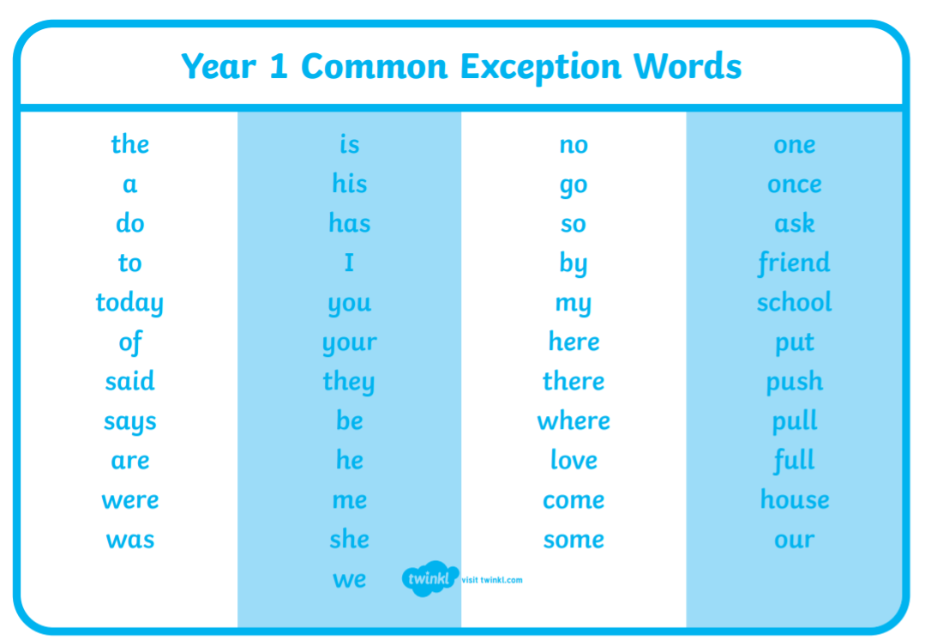
To practice reading these common exception words. You could:
- Hide them around your house. When you find them have a go at reading them.
- Run to the word an adult says.
Learn how to spell the 5 common exception words.
- Use a spelling app
- Read them, cover them up and try and remember how to spell them.
- Write them in the bath.

Story writing ideas



